# Prepare a test cases on Login Page of Gmail using Unit andSystem Testing

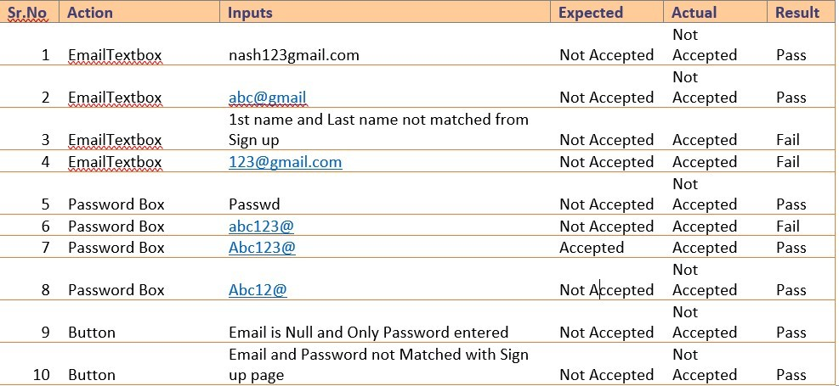

1. **Prepare a test case on Calculator using Unit and System Testing**

